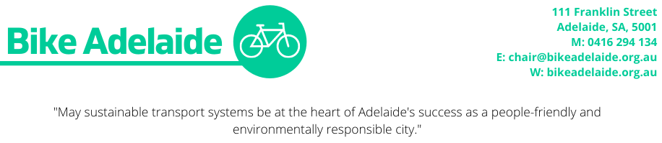

Hon. Corey Wingard 20 April 2021
Minister for Infrastructure and Transport
GPO Box 668, Adelaide, SA, 5001
ministerwingard@sa.gov.au

Increasing the State Bicycle Fund and delivering the Goodwood Bridge

Dear Minister Wingard,

Bike Adelaide (formerly the Bicycle Institute of South Australia) advocates for safe and inclusive cycling infrastructure in Greater Adelaide. We follow closely major project announcements and note a significant inequity in investment favouring motor vehicle infrastructure. These projects are frequently predicated on traffic volume and traffic time assumptions that are not borne out in practice Economic benefits of road widening: Discrepancy between outturn and forecast - ScienceDirect. In reality they are costly, harmful and ineffective at improving accessibility and reducing congestion.

We call on you to address this inequity by delivering investment in infrastructure that provides an alternative to motor vehicle use before our health budgets and transport emissions skyrocket further, and our citizens spend more and more time sitting in traffic.

As your department spends only 0.06% of investment expenditure on cycling infrastructure despite 2% of people cycling to work/study, the network is under resourced. Bike Adelaide calls on you to increase investment to 5% or $75 million per year to drive growth in bike mode share. Increasing the State Bicycle Fund is an easily accessible and effective strategy to partially allocate this funding and Bike Adelaide calls on you to provide the people of South Australia with a $10 million annual State Bicycle Fund budget.

The remaining budget would fund major cycling projects. One such project is the critically needed Goodwood Overpass Bridge along Adelaide’s most used cycleway, The Mike Turtur Bikeway. As the project has already received federal funding, properties have potentially been acquired and a positive cost benefit analysis result achieved, it is ready to go. Bike riding is the most popular outdoor recreational activity in South Australia. That gives you plenty of support. We are aware Unley BUG are supportive and have also written to you.

The previous Minister, Stephan Knoll, showed little interest in building a better community in Greater Adelaide. $30 million for a walking/cycling bridge was seen as too much however $100 million for one intersection expansion was considered OK. As someone with a broader interest in sport and recreation we are sure you do not share his view and we look forward to seeing action.

Kind regards,

Katie Gilfillan, Chairperson

